Max Levine, Yuchen Liu, and Qi Wang

Project link: https://mflevine.github.io/PokeVis/index.html

Description

A Visualization of Pokémon of the various generations to learn of about changes in type distributions, stats, and weights of Pokémon.

**PokéVis**

Process Book

Table of Contents

Overview and Motivation 2

Related Work 2

Questions 3

Data 3

Exploratory Data Analysis 4

Type Normalized Stack bar Chart 4

Design Evolution: 4

Implementation 7

Evaluation 8

Stat Radar Chart 8

Design Evolution 8

Implementation 12

Evaluation 12

Weight Bubble Chart 13

Design Evolution 13

Implementation 16

Evaluation 16

Reference 17

# Overview and Motivation

Our project will be based on the data set from Pokémon. Pokémon is a series of video games developed by Game Freak and Creatures Inc. Over the years, the game has been adapted to animated television shows and movies, comic books, and toys. Especially, in July 2016, a game for iOS and Android devices named Pokémon Go was released. After releasing, Pokémon Go has become the fastest game to top the App Store and Google Play. There is a popular trend to play this game around the world. Therefore, we think it would be meaningful to visualize the data in this series game. This kind of visualization would appeal all the people who played the game or heard of the game.

In the game, there are fictional species called Pokémon. By the end of year 2016, there were totally 802 Pokémon. All the Pokémon are divided roughly by generation. When each generation begins, the number of Pokémon and Pokémon properties will be updated. Our project will mainly focus on the change on each generation and each Pokémon.

# Related Work

This project was inspired by Tableau dashboard made by Jewel Loree, which can be found at <http://www.jewelloree.com/2013/11/06/pop-viz-gotta-viz-em-all/>. This dashboard allows the user to view all of the Pokémon on a scatterplot based on two stats, with the pictures of the Pokémon as the points. The user can change the stats that are used and filter by Pokémon type or search for a particular Pokémon of interest. We wanted to also do a Pokémon visualization and try some more creative ways to visualization that data associated with the Pokémon games.

# Questions

Firstly, we want to know the proportion of different type of Pokémon in each generation. Which type of Pokémon becomes much more prevalent in a new generation? We also want to know the profile for each Pokémon with respect to different properties. In addition, how do the properties of each type of Pokémon vary with generations? Apart from the base stats, we also want to describe the change of weight in different generation. After seeing our visualization, people will understand the Pokémon’s characteristic of different generation and easily know the advantages of different Pokémon.

# Data

We used two different data sources to ensure that we had type, weight, and stat data for every Pokémon. The data can be found at <https://www.kaggle.com/abcsds/pokemon> and <https://github.com/veekun/pokedex/blob/master/pokedex/data/csv/pokemon.csv>. File1: Pokémon with its combat attribute and File2: Pokémon with its size attributes. Firstly, File1 contains some duplicated data, such as there are three No.6 Pokémon with different name (in different version of game). We performed basic data cleaning by removing these duplications.

The attributes we planned to use: Pokémon id, name, type, total, HP, attack, defense, special attack, special defense, speed, generation, and weight. We also counted the number of Pokémon of each type for each generation.

# Exploratory Data Analysis

We ended up not performing much exploratory data analysis. For our initial look at the data, we looked at different previously created visualizers of Pokémon data. We then went straight into trying to make the visualizations that we originally set out to do and evolving them throughout the process.

# Type Normalized Stack bar Chart

## Design Evolution:

Firstly, we thought of a pie chart to show the distribution of type, and provide a drop down menu to let user choose the generation. However, later on we realized there are about 20 types in different generations, so some slices in the chart would be relatively hard to see, and pie chart makes user more difficult to do the comparison between different slice.

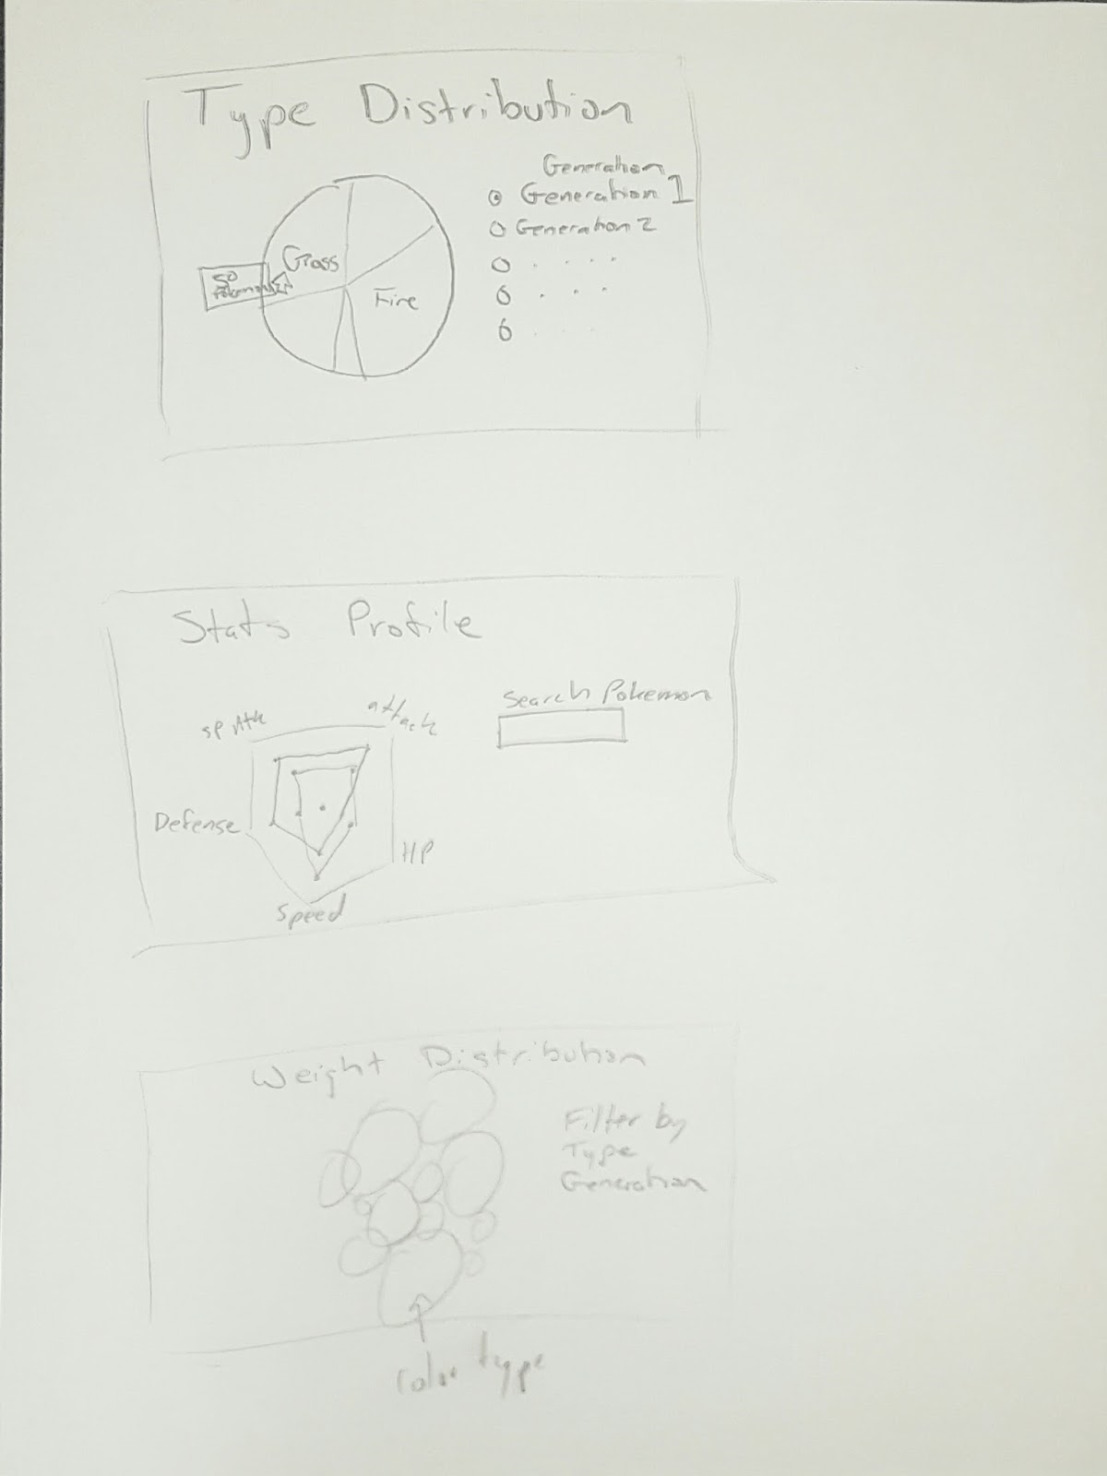

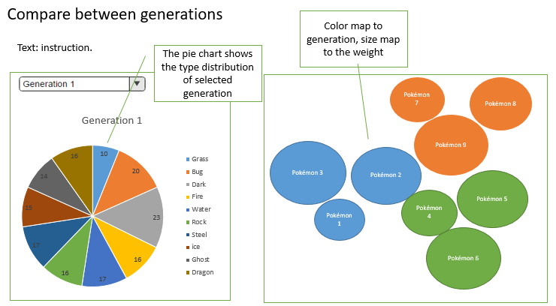

So we altered pie chart to a bar chart with a slider to change the generation, we also add the animation so that user can see clearly how the distribution changes from one generation to another. However, animation surely hides some information; user cannot see the distribution of type for all generation at once.

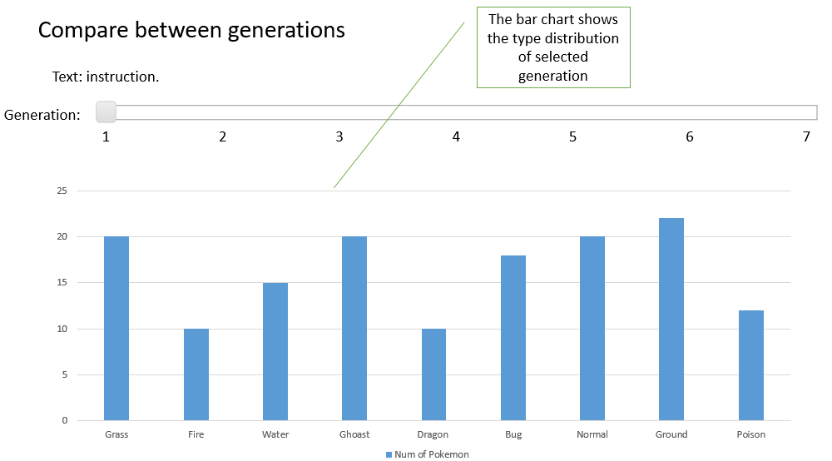

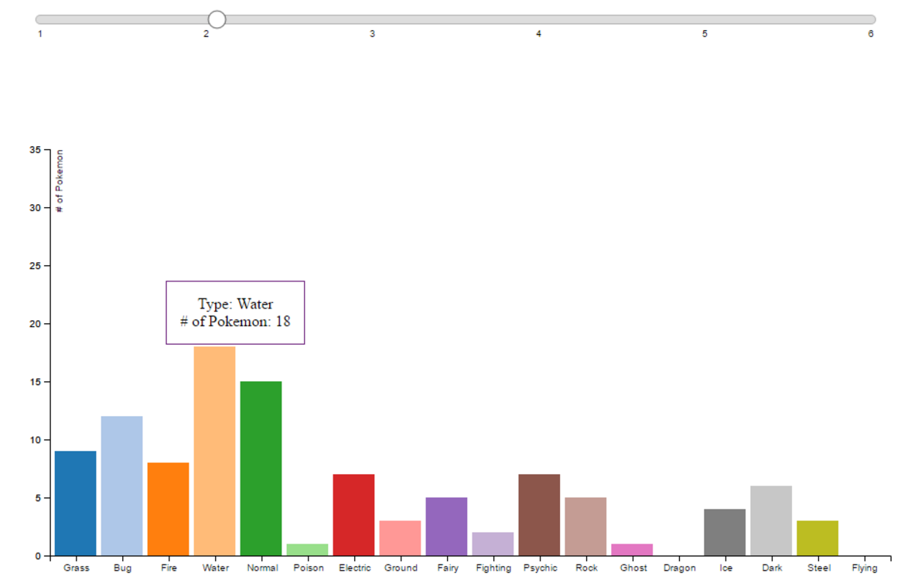

Finally, we decided on normalized bar chart. Comparing with pie chart, each type has its own bar, and comparing height is easier than comparing angle for user. Comparing with bar chart, user can see all the distribution at once, and no need to use the slider.

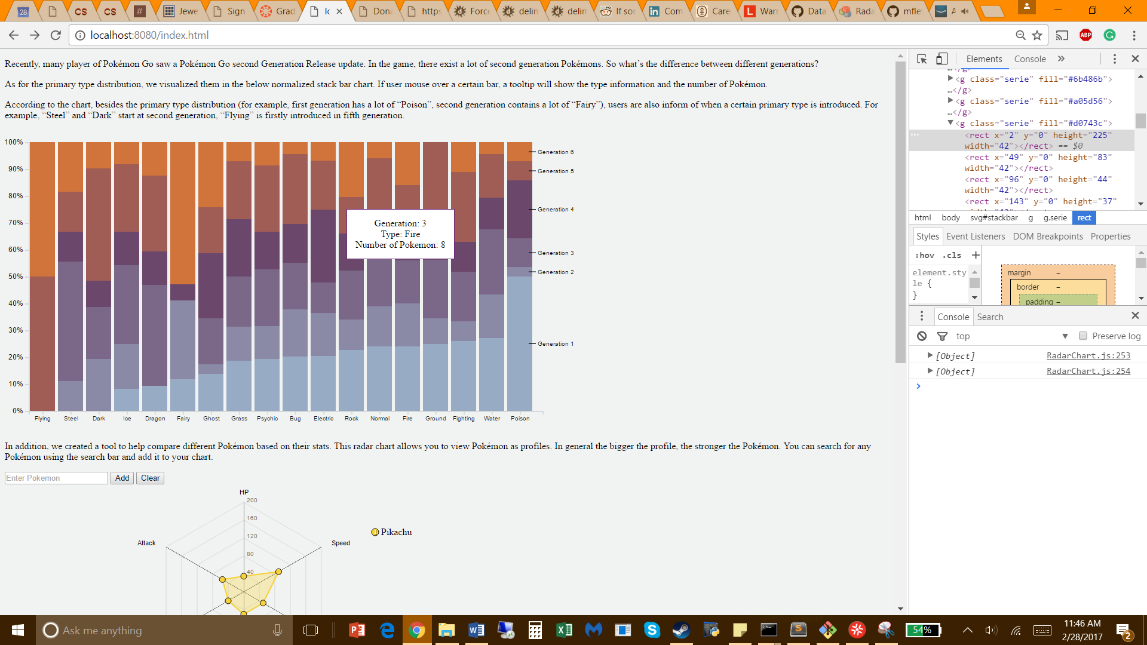

## Implementation

In the normalized stack bar chart, different types of Pokémon are mapped to different bar, and different generations are mapped to different color. The height of bar represents the percentage of Pokémon population in corresponding generation. If user moves mouse over a certain bar, a tooltip will shows aside about generation, type and population information.

## Evaluation

According to the chart, besides the primary type distribution (for example, first generation has a lot of the “Poison” Pokémon ever created, second generation contains a lot of the “Fairy” Pokémon ever created), users are also inform of when a certain primary type is introduced. For example, “Steel” and “Dark” start at second generation; “Flying” was first introduced in fifth generation.

# Stat Radar Chart

## Design Evolution

We knew that we wanted to visualize all of the Pokémon as numbers. We originally considered using parallel axes to visualize all the stats at one time but we did not think that would be visually appealing. As such, we decided that a radar chart would be more pleasing to the eye but still be helpful in comparing different Pokémon.

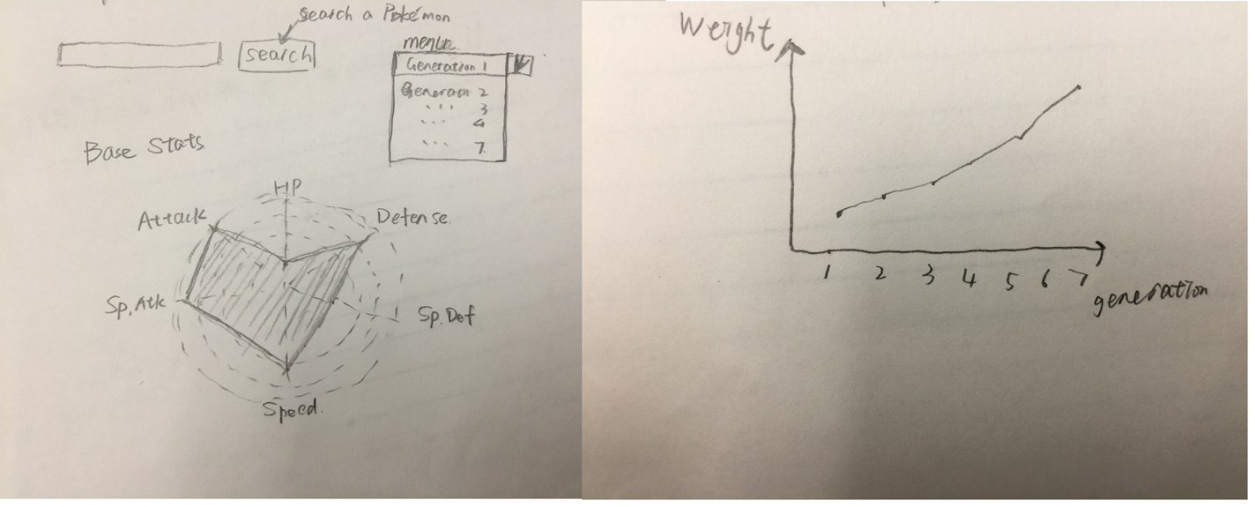

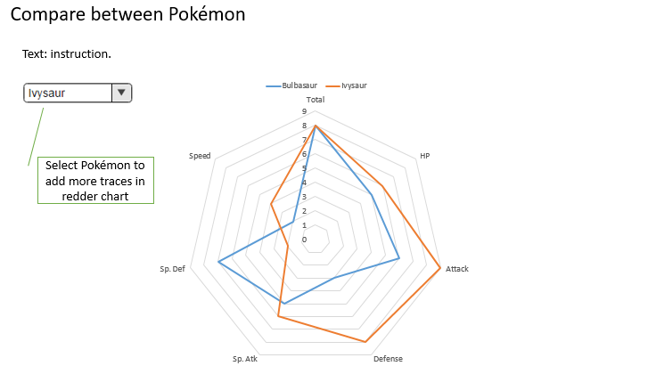

We found a radar chart script by Alan Dunning that worked in D3 V4 but had to heavily modify it to read from a csv file and work for our data. Our first version can be seen below.

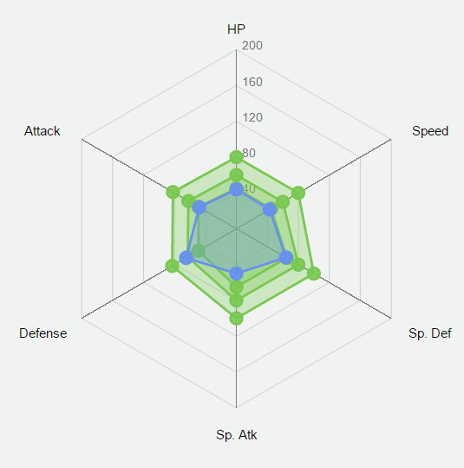

We then wanted to add a search and clear button so that the viewer could find and display any set of Pokémon that they wanted to. We had to change the search bar using with other scripts so that it would have a scroll bar. We also had the tooltip give the user the stat and name of the Pokémon when mousing over a point.

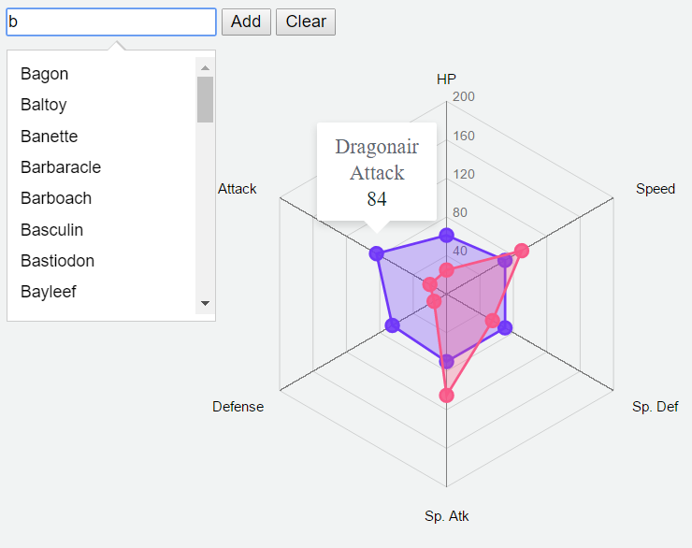

Next, we thought that it would make sense to add a legend so that the user could know which Pokémons the user is looking at. In addition, we added a tooltip to show which Pokémon the viewer is hovering over.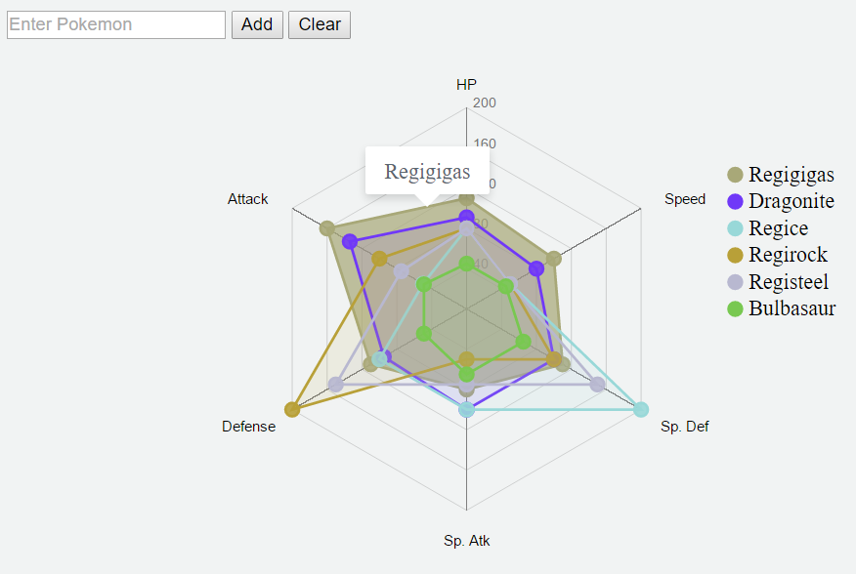

The final touch that we added to this visualization was a popup of the Pokémon, when you hover over its trace, as seen below. We also put the generation of the Pokémon in the legend to help the viewer compare stats from different generation.

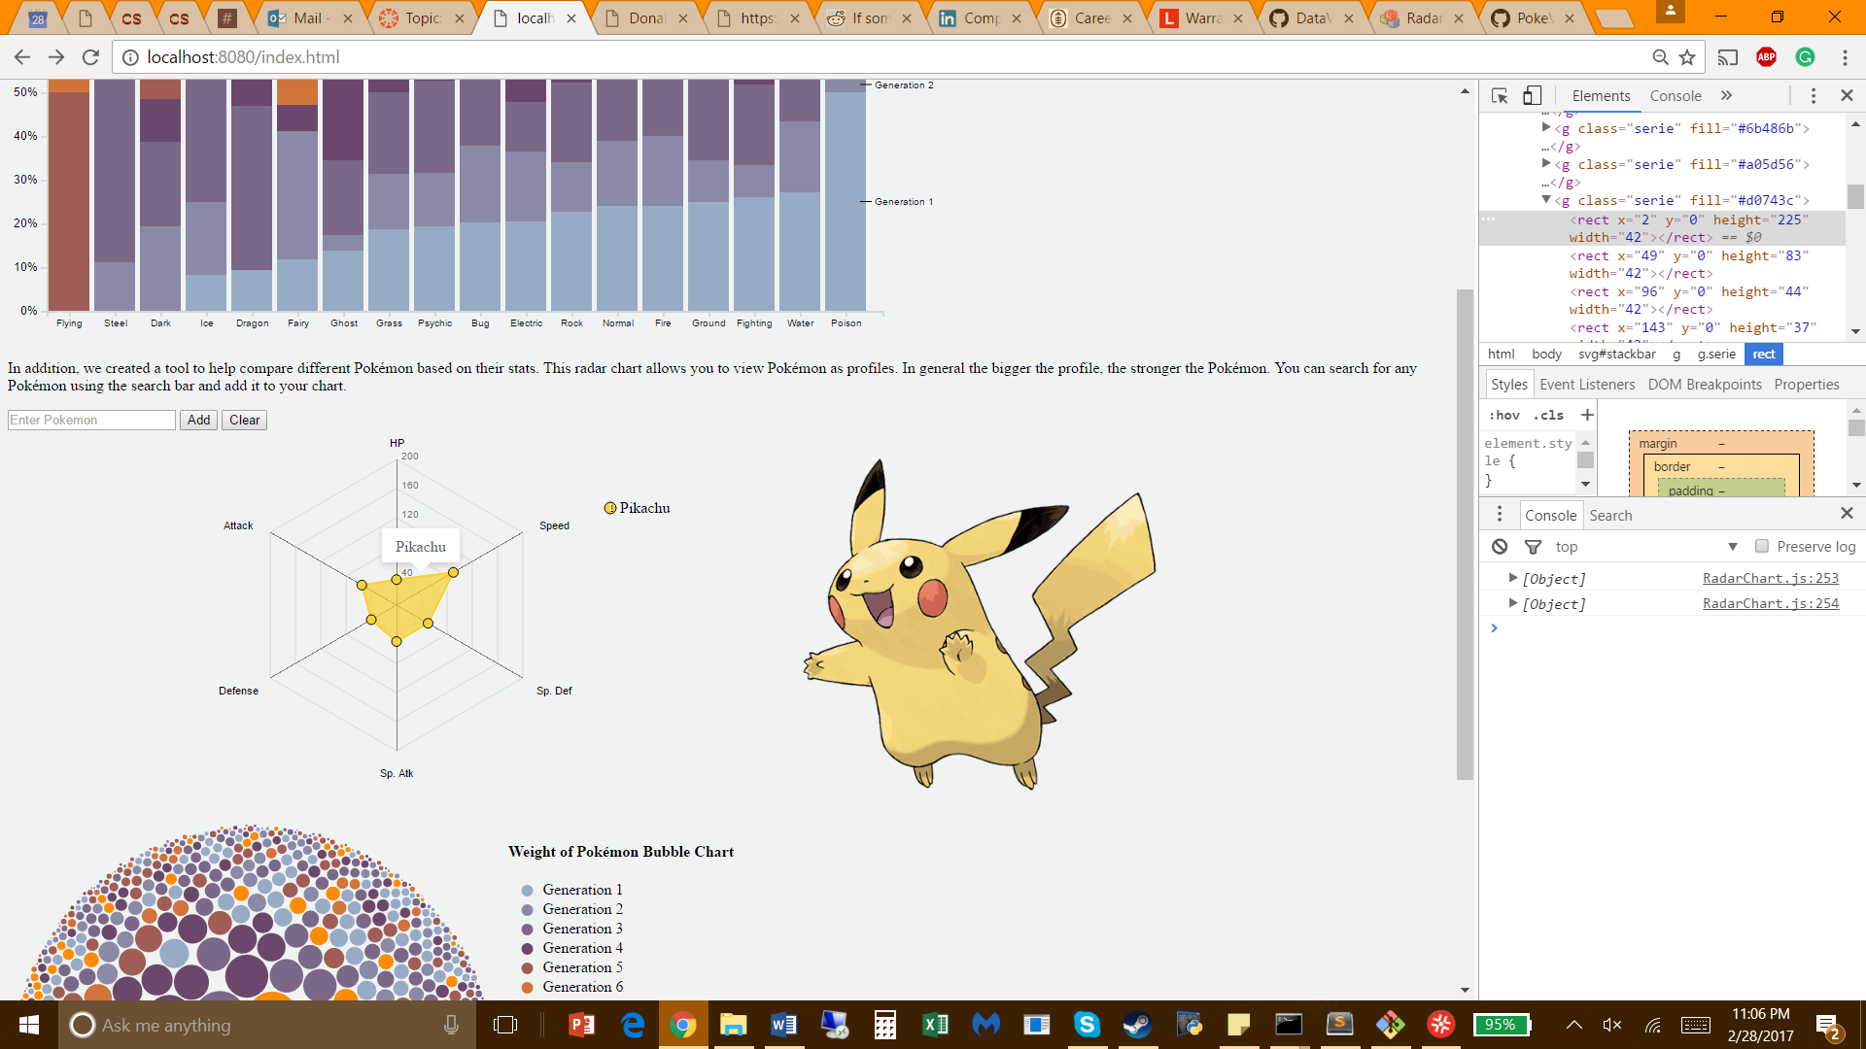

## Implementation

This visualization has multiple interactive components, which are referenced in the images above. First, the user can add Pokémon of their choosing to the radar using a search bar. The profiles are then created with color encoding the type of the Pokémon. There are two different tooltips, one for the polygon of the profile and one for the points representing the stats. When mousing over the polygon, the name of the Pokémon is displayed and its image can be seen on the right. When mousing over the points, the user can view the Pokémon name, the stat, and the value.

## Evaluation

This radar chart can be used to compare different Pokémon and could even be used to compare stats from different generations. User can use this tool to help build a well-balanced team since it provides type and stat encodings. This visualization performs well in what we set out to do and is visually pleasing. In the future, we could allow the user to drag the points along the axes in order to search for Pokémon with those stats. This could further help them pick a team for ultimate victory.

# Weight Bubble Chart

## Design Evolution

We first decided to use a bubble chart with the image of each Pokémon in the middle of the circle to visualize the weight of Pokémon. The radius of bubbles stands for the weight of each Pokémon.

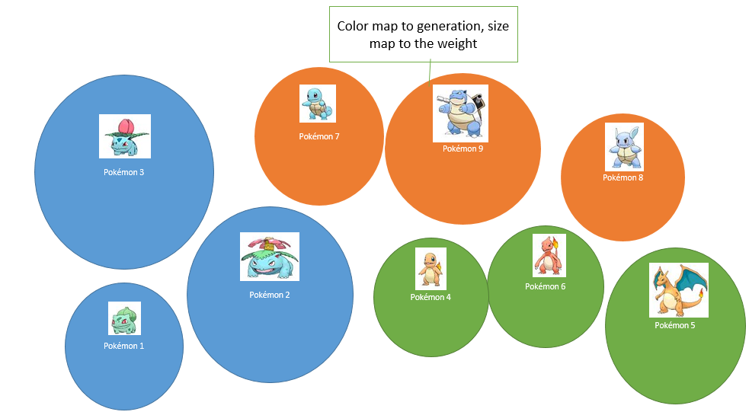

However, after realizing the first version of the bubbles, we found that there are over eight hundred bubbles and they are too tiny to accommodate a picture in them.

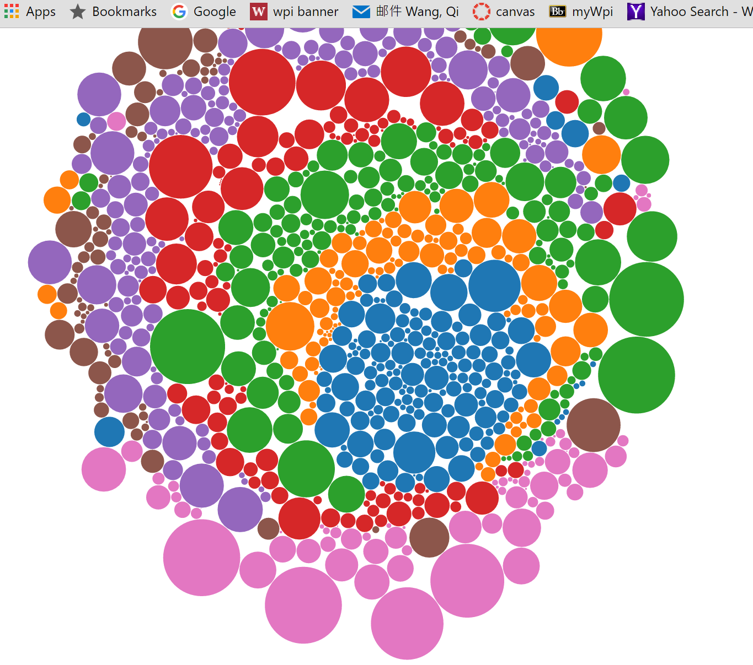

In order to solve this problem, we changed the images to tooltips of each bubble.

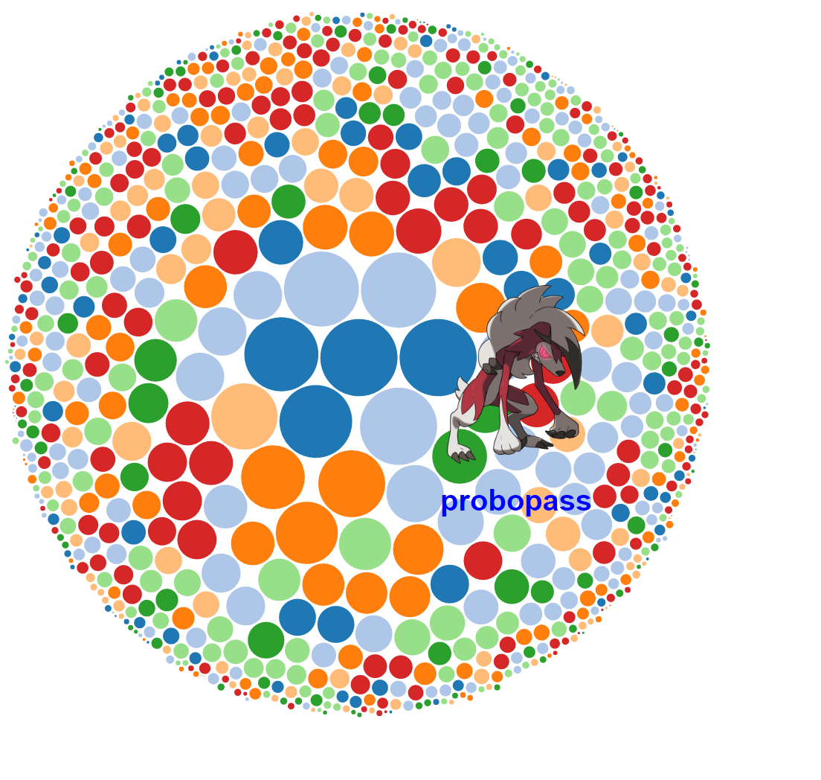

As for the perceptual and design principles, in order to make it easy to discriminate each generation, we used the colors, which are the same as our normalized stack bar chart. We included a legend and sorted the bubbles from big to small.

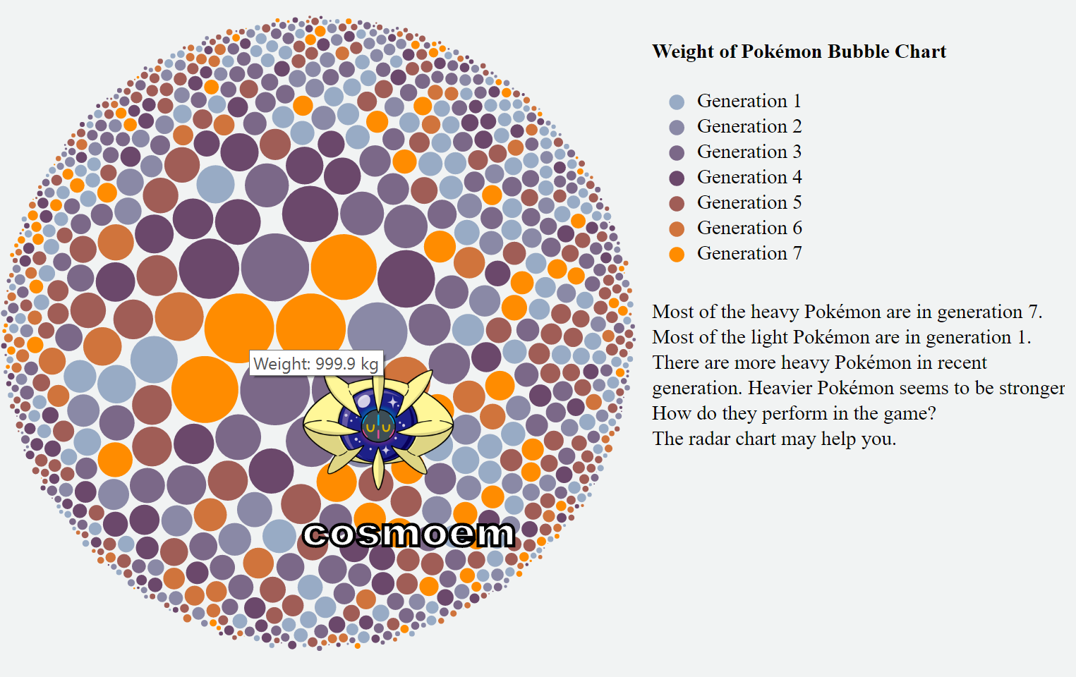

## Implementation

The interaction element of bubble chart is tooltips. When the mouse is over a bubble, the tooltip will show the image and name of that Pokémon. We set the stroke and color of text to make it more evident from the background. This can be seen above.

## Evaluation

From the bubble chart, we learned that most of the heavy Pokémon are in generation 7 (orange bubbles). Most of the light Pokémon are in generation 1 (blue bubbles). There are heavier Pokémon in recent generations. Also, we can easily find the heaviest Pokémon from the bubble chart and see the appearance of them. To further improve the bubble chart, we could use the force layout to make the Pokémon of the same type or generation in the same cluster. This could also add more interaction elements.

# Reference

* <http://www.jewelloree.com/2013/11/06/pop-viz-gotta-viz-em-all/>
* <https://www.kaggle.com/abcsds/pokemon>
* <https://github.com/veekun/pokedex/blob/master/pokedex/data/csv/pokemon.csv>
* <http://pokemondb.net/>
* <https://modernizr.com/>